Ideation Phase
Empathize & Discover
Empathy Map Canvas
An empathy map helps the team understand a user’s behaviours, attitudes, goals, and challenges. For the Medical Diagnosis Center (MDC), the primary user is a patient who books a diagnostic test, tracks the appointment, and accesses the report online.
Date | 14 October 2026
Team ID | ServiceNow - 92
Project Name | Medical Diagnosis Center (MDC)
Maximum Marks | 4 Marks

Empathy Map Canvas — Patient Experience
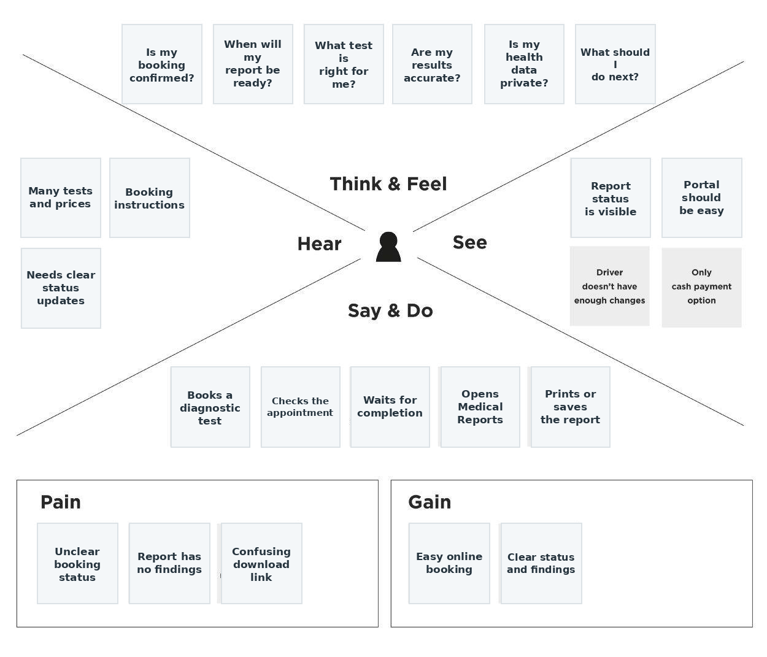

Medical Diagnosis Center (MDC)
Empathy Map Canvas — Detailed View

